Order of Service in Church

ALL STAND as the funeral procession enters the church. Once the family are seated, please SIT

The Priest reads one or more scriptural sentences.

Introduction

Priest: We meet in the name of Jesus Christ, who died and was raised to the glory of God the Father. Grace and mercy be with you.
All: Amen.

The priest introduces the service

Priest: Let us pray. ( please remain seated)

Almighty God, you judge us with infinite mercy and justice, and love everything you have made. In your mercy turn the darkness of death into the dawn of new life, and the sorrow of parting into the joy of heaven; through our Saviour, Jesus Christ. Amen

Priest: Merciful Father, hear our prayers and comfort us; renew our trust in your Son, whom you raised from the dead; strengthen our faith that all who have died in the love of Christ will share in his resurrection; who lives and reigns with you, in the unity of the Holy Spirit, one God, now and for ever. Amen

The Ministry of the Word

Hymn or Psalm (Please stand. You will find the hymn or psalm in the back of this booklet, or the hymn book)

Reading
Please sit: for a reading from the Old or New Testament.

The Address.

(A hymn may be sung)
The Prayers:

Priest: God of mercy, Lord of life, you have made us in your image to reflect your truth and light: we give you thanks for N , for the grace and mercy he/she received from you, for all that was good in his/her life, for the memories we treasure today.

(after a short period of silence)

Priest: Lord, in your mercy
All: hear our prayer.

Priest: You promised eternal life to those who believe. Remember for good this your servant N as we also remember him/her. Bring all who rest in Christ into the fullness of your kingdom where sins have been forgiven and death is no more.

(after a short period of silence)

Priest: Lord, in your mercy
All: hear our prayer.

Priest: Your mighty power brings joy out of grief and life out of death. Look in mercy on … and all who mourn. Give them patient faith in times of darkness. Strengthen them with the knowledge of your love.

(after a short period of silence)

Priest: Lord, in your mercy
All: hear our prayer.

Priest: You are tender towards your children and your mercy is over all your works. Heal the memories of hurt and failure. Give us the wisdom and grace to use aright the time that is left to us here on earth, to turn to Christ and follow in his steps in the way that leads to everlasting life.

(after a short period of silence)

Priest: Lord, in your mercy
All: hear our prayer.

All: God of mercy, entrusting into your hands all that you have made and rejoicing in our communion with all your faithful people, we make our prayers through Jesus Christ our Saviour. Amen.

Priest: Let us pray with confidence as our Saviour has taught us
All: Our Father, who art in heaven, hallowed be thy name; thy kingdom come; thy will be done; on earth as it is in heaven. Give us this day our daily bread. And forgive us our trespasses, as we forgive those who trespass against us. And lead us not into temptation; but deliver us from evil. For thine is the kingdom, the power and the glory, for ever and ever. Amen.

Hymn: (from the back of this booklet, or the hymn book).

Commendation and farewell [please remain standing]

The coffin may be sprinkled with water

Priest: With this water we call to mind N’s baptism. As Christ went through the deep waters of death for us, so may he bring us to the fullness of resurrection life with N and all the redeemed.

Priest: Let us commend N to the mercy of God our Maker and Redeemer.

God our creator and redeemer, by your power Christ conquered death and entered into glory. Confident of his victory and claiming his promises, we entrust N to your mercy in the name of Jesus our Lord, who died and is alive and reigns with you, now and for ever. Amen

All: Heavenly Father, in your Son Jesus Christ you have given us a true faith and a sure hope. Strengthen this faith and hope in us all our days, that we may live as those who believe in the communion of saints, the forgiveness of sins and the resurrection to eternal life; through Jesus Christ our Lord. Amen.

Priest: May God, in his infinite love and mercy, bring the whole Church, living and departed in the Lord Jesus, to a joyful resurrection, and the fulfilment of his eternal kingdom. Amen.

As the procession leaves church, the Nunc Dimittis may be read. Please follow the family.

Acknowledgement: Common Worship: Pastoral Services, material from which is included in this service, is copyright © The Archbishops’ Council (2000)
Hymn Supplement

1. |  | Abide with me; fast falls the eventide:  the darkness deepens; Lord, with me abide:  when other helpers fail, and comforts flee,  help of the helpless, O abide with me.  Swift to its close ebbs out life's little day;  earth's joys grow dim, its glories pass away;  change and decay in all around I see:  O thou who changest not, abide with me.  I need thy presence every passing hour;  what but thy grace can foil the tempter's power?  Who like thyself my guide and stay can be?  Through cloud and sunshine, Lord, abide with me.  I fear no foe with thee at hand to bless;  ills have no weight, and tears no bitterness,  Where is death's sting? Where, grave, thy victory?  I triumph still, if thou abide with me.  Hold thou thy cross before my closing eyes;  shine through the gloom, and point me to the skies:  heaven's morning breaks, and earth's vain shadows flee;  in life, in death, O Lord, abide with me.
2. |  |  |  | All things bright and beautiful,  all creatures great and small,  all things wise and wonderful,  the Lord God made them all.  Each little flower that opens,  each little bird that sings,  he made their glowing colours,  he made their tiny wings:  The purple headed mountain,  the river running by,  the sunset, and the morning  that brightens up the sky:
The cold wind in the winter,
the pleasant summer sun,
the ripe fruit in the garden,
he made them every one:

He gave us eyes to see them,
and lips that we might tell
how great is God almighty,
who has made all things well:

All things bright and beautiful,
all creatures great and small,
all things wise and wonderful,
the Lord God made them all.

3. |  |  |  | Amazing grace,  How sweet the sound that saved a wretch like me.  I once was lost but now I'm found,  Was blind, but now can see.  'Twas grace that taught my heart to fear,  And grace my fears relieved,  How precious did that grace appear  The hour I first believed.  Through many dangers, toils and snares,  I have already come.  'Tis grace hath brought me safe thus far,  And grace will lead me home.  The Lord has promised good to me;  His word my hope secures.  He will my shield and portion be  As long as life endures.
 | 4. |  | And did those feet in ancient time  walk upon England's mountains green?  And was the holy Lamb of God  on England's pleasant pastures seen?  And did that countenance divine  shine forth upon our clouded hills?  And was Jerusalem builded here  among those dark satanic mills?  Bring me my bow of burning gold!  Bring me my arrows of desire!  Bring me my spear! O clouds, unfold!  Bring me my chariot of fire!  I will not cease from mental fight,  nor shall my sword sleep in my hand,  till we have built Jerusalem  in England's green and pleasant land
 | 5. |  | Guide me, O thou great Redeemer,  pilgrim through this barren land;  I am weak, but thou art mighty;  hold me with thy powerful hand:  bread of heaven, bread of heaven,  feed me now and evermore.  Open now the crystal fountain  whence the healing stream doth flow;  let the fiery cloudy pillar  lead me all my journey through;  strong deliverer, strong deliverer  be thou still my strength and shield
When I tread the verge of Jordan,
bid my anxious fears subside;
death of death, and hells destruction,
land me safe on Canaan's side:
songs and praises, songs of praises,
I will ever give to thee.
 | 6. |  | I watch the sunrise lighting the sky,  casting its shadow near;  and on this morning, bright though it be,  I feel those shadows near me.  But you are always close to me,  following all my ways.  May I be always close to you,  following all your ways, Lord.  I watch the sunlight shine through the clouds  warming the earth below;  and at the mid-day life seems to say:  "I feel your brightness near me."  But you are always close to me ...  I watch the sunset fading away  lighting the clouds with sleep;  and as the evening closes its eyes  I feel your presence near me.  But you are always close to me ...  I watch the moonlight guarding the night,  waiting till morning comes.  The air is silent, earth is at rest -  only your peace is near me.  But you are always close to me ...
 | 7. |  | Lead us, heavenly Father, lead us  o'er the world's tempestuous sea;  guard us, guide us, keep us, feed us,  for we have no help but thee;  yet possessing every blessing,  if our God our Father be.  Saviour, breathe forgiveness o'er us:  all our weakness thou dost know;  thou didst tread this earth before us,  thou didst feel its keenest woe;  lone and dreary, faint and weary,  through the desert thou didst go.  Spirit of our God, descending,  fill our hearts with heavenly joy,  love with every passion blending,  pleasure that can never cloy:  thus provided, pardoned, guided,  nothing can our peace destroy.
 | 8. |  | Lord of all hopefulness, Lord of all joy,  whose trust, ever childlike, no cares could destroy,  be there at our waking, and give us, we pray,  your bliss in our hearts, Lord, at the break of the day.
Lord of all eagerness, Lord of all faith,
whose strong hands were skilled at the plane and the lathe,
be there at our labours, and give us, we pray,
your strength in our hearts, Lord, at the noon of the day.

Lord of all kindliness, Lord of all grace,
your hands swift to welcome, your arms to embrace,
be there at our homing, and give us, we pray,
your love in our hearts, Lord, at the eve of the day.

Lord of all gentleness, Lord of all calm,
whose voice is contentment, whose presence is balm,
be there at our sleeping, and give us, we pray,
your peace in our hearts, Lord, at the end of the day.
 | 9. |  | Love divine, all loves excelling,  joy of heaven, to earth come down,  fix in us thy humble dwelling,  all thy faithful mercies crown.  Jesu, thou art all compassion,  pure unbounded love thou art;  visit us with thy salvation,  enter every trembling heart.  Come, almighty to deliver,  let us all thy grace receive;  suddenly return, and never,  never more thy temples leave.  Thee we would be always blessing,  serve thee as thy hosts above;  pray, and praise thee, without ceasing,  glory in thy perfect love.  Finish then thy new creation:  pure and spotless let us be;  let us see thy great salvation,  perfectly restored in thee;  changed from glory into glory,  till in heaven we take our place,  till we cast our crowns before thee,  lost in wonder, love and praise
 | 10. |  | Make me a channel of your peace.  Where there is hatred let me bring your love.  where there is injury, your pardon, Lord,  and where there's doubt, true faith in you.  Oh Master, grant that I may never seek  so much to be consoled as to console,  to be understood, as to understand,  to be loved, as to love with all my soul.  Make me a channel of your peace.  Where there's despair in life, let me bring hope.  Where there is darkness, only light,  and where there's sadness, ever joy.  Oh Master, grant that I may never seek  so much to be consoled as to console,  to be understood, as to understand,  to be loved, as to love with all my soul.  Make me a channel of your peace.  It is in pardoning that we are pardoned,  in giving to all men that we receive,  and in dying that we're born to eternal life.
 | 11. |  | Morning has broken like the first morning,  Blackbird has spoken like the first bird,  Praise for the singing. Praise for the morning.  Praise for them, springing fresh from the world
Sweet the rain's new fall sunlit from heaven,
Like the first dewfall on the first grass.
Praise for the sweetness of the wet garden,
Sprung in completeness where his feet pass.

Mine is the sunlight. Mine is the morning
Born of the one light Eden saw play.
Praise with elation, praise every morning,
Gods re-creation of the new day.

 | 12. |  | O Lord my God! When I in awesome wonder  Consider all the works Thy hand hath made,  I see the stars, I hear the mighty thunder,  Thy power throughout the universe displayed:  Then sings my soul, my Saviour God to Thee,  How great Thou art! How great Thou art!  Then sings my soul, my Saviour God to Thee,  How great Thou art! How great Thou art!  When through the woods and forest glades I wander  And hear the birds sing sweetly in the trees;  When I look down from lofty mountain grandeur,  And hear the brook, and feel the gentle breeze;  Then sings my soul ...  And when I think that God his Son not sparing,  Sent Him to die - I scarce can take it in;  That on the cross my burden gladly bearing,  He bled and died to take away my sin:  Then sings my soul ...  When Christ shall come with shout of acclamation  And take me home - what joy shall fill my heart!  Then shall I bow in humble adoration  And there proclaim my God, how great Thou art!  Then sings my soul ...
 | 13. |  | O love that wilt not let me go,  I rest my weary soul in Thee:  I give Thee back the life I owe,  That in Thine ocean depths its flow  May richer, fuller be.  O Light that followest all my way,  I yield my flick'ring torch to Thee:  My heart restores its borrow'd ray,  That in Thy sunshine's blaze its day  May brighter, fairer be.  O Joy that seekest me through pain,  I cannot close my heart to Thee;  I trace the rainbow through the rain,  And feel the promise is not vain  That morn shall tearless be.  O Cross that liftest up my head,  I dare not ask to fly from Thee:  I lay in dust life's glory dead,  And from the ground there blossoms red  Life that shall endless be.
 | 14. |  | On a hill far away stood an old rugged cross,  The emblem of suff'ring and shame;  and I love that old cross where the dearest and best  For a world of lost sinners was slain.  So I'll cherish the old rugged cross  Till my trophies at last I lay down;  I will cling to the old rugged cross  And exchange it some day for a crown.
To the old rugged cross I will ever be true,
Its shame and reproach gladly bear;
Then He'll call me some day to my home far away,
Where his glory for ever I'll share.

So I'll cherish the old rugged cross
Till my trophies at last I lay down;
I will cling to the old rugged cross
And exchange it some day for a crown.

 | 15. |  | Praise, my soul, the King of heaven,  to his feet thy tribute bring;  ransomed, healed, restored, forgiven,  who like me his praise should sing?  Alleluia, Alleluia,  praise the everlasting King.  Praise him for his grace and favour  to our fathers in distress;  praise him still the same as ever,  slow to chide and swift to bless:  Alleluia, Alleluia,  glorious in his faithfulness.  Father-like, he tends and spares us,  well our feeble frame he knows;  in his hands he gently bears us,  rescues us from all our foes:  Alleluia, Alleluia,  widely as his mercy flows.  Angels, help us to adore him;  ye behold him face to face;  sun and moon, bow down before him,  dwellers all in time and space:  Alleluia, Alleluia,  praise with us the God of grace.
 | 16. |  | The day thou gavest, Lord, is ended,  the darkness falls at thy behest;  to thee our morning hymns ascended,  thy praise shall sanctify our rest.  We thank that thy Church unsleeping,  while earth rolls onward into light,  through all the world her watch is keeping,  and rests not now by day nor night.
As o'er each continent and island
the dawn leads on another day,
the voice of prayer is never silent,
nor dies the strain of praise away.

The sun that bids us rest is waking -
our brethren 'neath the western sky,
and hour by hour fresh lips are making -
thy wondrous doings heard on high.

So be it, Lord; thy throne shall never,
like earth's proud empires, pass away;
thy kingdom stands, and grows for ever,
till all thy creatures own thy sway.

 | 17. |  | The King of love my shepherd is,  whose goodness faileth never;  I nothing lack if I am his  and he is mine for ever.  Where streams of living water flow  my ransomed soul he leadeth,  and where the verdant pastures grow  with food celestial feedeth.  Perverse and foolish oft I strayed,  but yet in love he sought me,  and on his shoulder gently laid,  and home rejoicing brought me.  In death's dark vale I fear no ill  with thee dear Lord beside me;  thy rod and staff my comfort still,  thy cross before to guide me.
Thou spread'st a table in my sight;
thy unction grace bestoweth;
and O what transport of delight
from thy pure chalice floweth!

And so through all the length of days
thy goodness faileth never:
good Shepherd, may I sing thy praise
within thy house for ever.

 | 18. |  | The Lord's my Shepherd, I'll not want;  he makes me down to lie -  in pastures green; he leadeth me -  the quiet waters by.  My soul he doth restore again,  and me to walk doth make -  within the paths of righteousness,  e'en for his own name's sake.  Yea, though I walk through death's dark vale,  yet will I fear no ill;  for thou art with me, and thy rod -  and staff me comfort still.  My table thou hast furnished  in presence of my foes;  my head thou dost with oil anoint ,  and my cup overflows.  Goodness and mercy all my life  shall surely follow me;  and in God's house, for evermore  my dwelling place shall be.
 | 19. |  | On a hill far away stood an old rugged cross,  The emblem of suff'ring and shame;  and I love that old cross where the dearest and best  For a world of lost sinners was slain.  So I'll cherish the old rugged cross  Till my trophies at last I lay down;  I will cling to the old rugged cross  And exchange it some day for a crown.  Oh, the old rugged cross, so despised by the world,  Has a wondrous attraction for me;  For the dear Lamb of God left his glory above  To bear it to dark Calvary.  So I'll cherish the old rugged cross ...  In the old rugged cross, stained with blood so divine,  A wondrous beauty I see;  For 'twas on that old cross Jesus suffered and died  To pardon and sanctify me.  So I'll cherish the old rugged cross ...  To the old rugged cross I will ever be true,  Its shame and reproach gladly bear;  Then He'll call me some day to my home far away,  Where his glory for ever I'll share.  So I'll cherish the old rugged cross ...
 | 20. |  | There is a green hill far away,  without a city wall,  where the dear Lord was crucified,  who died to save us all.  We may not know, we cannot tell,  what pains he had to bear,  but we believe it was for us  he hung and suffered there.  He died that we might be forgiven,  he died to make us good,  that we might go at last to heaven,  saved by his precious blood.  There was no other good enough  to pay the price of sin;  he only could unlock the gate -  to heaven, and let us in.  O dearly, dearly has he loved,  and we must love him too,  and trust in his redeeming blood,  and try his work to do.
 | 21. |  | Thine be the glory, risen, conquering Son,  endless is the victory thou o'er death has won;  angels in bright raiment rolled the stone away,  kept the folded grave-clothes where thy body lay.  Thine be the glory, risen, conquering Son,  endless is the victory thou o'er death hast won.  Lo, Jesus meets us, risen from the tomb;  lovingly he greets us, scatters fear and gloom;  let the Church with gladness hymns of triumph sing,  for her Lord now liveth, death hath lost its sting:  No more we doubt thee, glorious Prince of Life;  life is naught without thee: aid us in our strife;  make us more than conquerors through thy deathless love;  bring us safe through Jordan to thy home above.
 | 22. |  | Psalm 23:  1 The Lord is my shepherd; therefore can I lack nothing.  2 He makes me lie down in green pastures  and leads me beside still waters.  3 He shall refresh my soul and guide me  in the paths of righteousness for his name’s sake.  4 Though I walk through the valley of the shadow of death,  I will fear no evil;  for you are with me; your rod and your staff, they comfort me.  5 You spread a table before me  in the presence of those who trouble me;  you have anointed my head with oil and my cup shall be full.  6 Surely goodness and loving mercy  shall follow me all the days of my life,  and I will dwell in the house of the Lord for ever.  Glory be to the Father, and to the Son,  and to the Holy Spirit:  As it was in the beginning, is now, and ever shall be:  world without end. Amen.
 | 23. |  | Nunc Dimittis (The Song of Simeon)  1 Now, Lord, you let your servant go in peace:  your word has been fulfilled.  2 My own eyes have seen the salvation  which you have prepared in the sight of every people;  3 A light to reveal you to the nations  and the glory of your people Israel.  Glory be to the Father, and to the Son,  and to the Holy Spirit:  As it was in the beginning, is now, and ever shall be:  world without end. Amen.
 | 24. |  | Be still, my soul: the Lord is at your side;  bear patiently the cross of grief and pain;  leave to your God to order and provide;  in every change he faithful will remain.  Be still, my soul: your best, your heavenly friend  through thorny ways leads to a joyful end.  Be still, my soul: your God will undertake  to guide the future as he has the past.  Your hope, your confidence let nothing shake,  all now mysterious shall be clear at last.  Be still, my soul: the tempests still obey  his voice, who ruled them once on Galilee.  Be still, my soul: the hour is hastening on  when we shall be for ever with the Lord,  when disappointment, grief and fear are gone,  sorrow forgotten, love's pure joy restored.  Be still, my soul: when change and tears are past,  all safe and blessed we shall meet at last.

The Parish Church of St Andrew

Orford with Longford

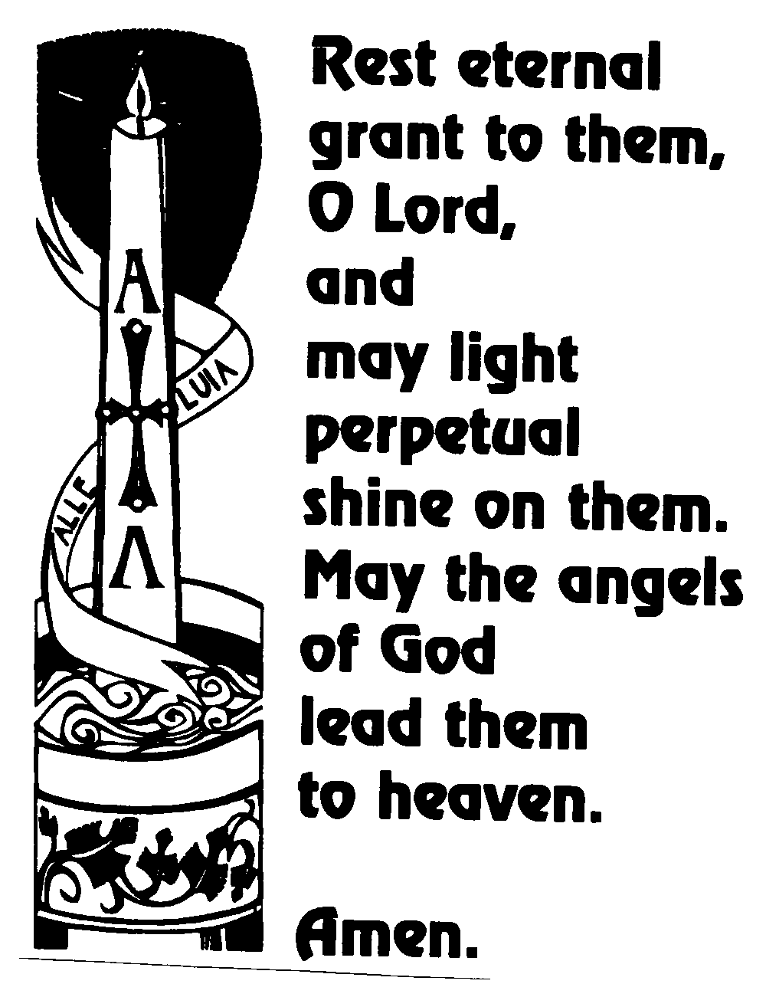

FUNERAL SERVICE

I am sure that neither life nor death, nor angels, nor principalities nor powers, nor things present, nor things to come, nor height, nor depth, nor anything else in all creation can separate us from the love of God in Christ Jesus our Lord.

In the quiet before the service, please pray
for the soul of the person departed and
for members of their family

God’s love and power extend over all creation. Every life, including our own, is precious to God. Christians have always believed that there is hope in death as in life, and that there is new life in Christ over death.

Even those who share such faith find that there is a real sense of loss at the death of a loved one. We will each have had our own experiences of their life and death, with different memories and different feelings of love, grief and respect. To acknowledge this at the beginning of the service should help us to use this occasion to express our faith and our feelings as we say farewell, to acknowledge our loss and our sorrow, and to reflect on our own mortality. Those who mourn need support and consolation. Our presence here today is part of that continuing support.

A collection will not taken during the service,
but there will be an opportunity on leaving church
to make a donation in thanksgiving
for the life of the departed and
towards the upkeep of the church.

Please do not remove this booklet from Church

